
PATUAKHALI SCIENCE AND TECHNOLOGY UNIVERSITY
COURSE CODE CCE-211

SUBMITTED TO:

Prof. Dr. Md Samsuzzaman

Department of Computer and Communication Engineering
Faculty of Computer Science and Engineering

SUBMITTED BY:
Md. Sharafat Karim
ID: 2102024,
Registration No: 10151
Faculty of Computer Science and Engineering

Date of submission: 3 May, 2024
Assignment 03
Assignment title: Chapter 03

Q3-1. What is the relationship between period and frequency?
The relationship is, , where, T = time period and f = frequency.

Q3-2. What does the amplitude of a signal measure? What does the frequency of a signal measure? What does the phase of a signal measure?
Amplitude: The amplitude of a periodic variable is a measure of its change in a single period.
Frequency: Frequency is the rate of change with respect to time.
Phase: Phase describes the position of the waveform relative to time 0.

Q3-3. How can a composite signal be decomposed into its individual frequencies?
A composite signal can be decomposed into its individual frequencies using Fourier transform.

Q3-4. Name three types of transmission impairment.
Three types of transmission impairment are
- Attenuation
- Distortion
- Noise.

Q3-5. Distinguish between baseband transmission and broadband transmission.
Baseband: Baseband transmission means sending a digital signal over a channel without changing the digital signal to an analog signal.
Broadband: Broadband transmission or modulation means changing the digital signal to an analog signal for transmission

Q3-6. Distinguish between a low-pass channel and a band-pass channel.
Low-pass channel: A channel that passes frequencies between 0 and f.
Band-pass channel: A channel that can pass a range of frequencies.

Q3-7. What does the Nyquist theorem have to do with communications?
The Nyquist bit rate formula defines the theoretical maximum
bit rate and thus helps us to implement a proper method considering the probability of losses.
Q3-8. What does the Shannon capacity have to do with communications?
The Shannon capacity gives us a theoretical highest data rate for a noisy channel.

Q3-9. Why do optical signals used in fiber optic cables have a very short wave length?
We know that, . In cables propagation is less than that of vacuums. So the wavelength is kept short.

Q3-10. Can we say whether a signal is periodic or nonperiodic by just looking at its frequency domain plot? How?
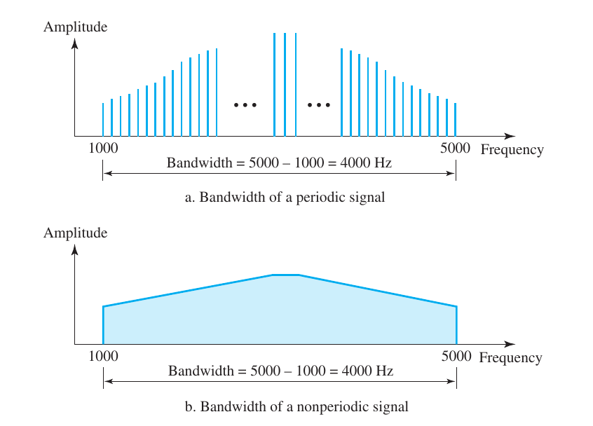
A periodic signal has discrete frequencies, where nonperiodic signal has continuous values.

Q3-11. Is the frequency domain plot of a voice signal discrete or continuous?
The frequency domain plot of a voice signal will be continuous.

Q3-12. Is the frequency domain plot of an alarm system discrete or continuous?
The frequency domain plot of an alarm signal will be discrete.

Q3-13. We send a voice signal from a microphone to a recorder. Is this baseband or broadband transmission?
Sending a voice signal from a microphone to a recorder is generally a baseband transmission.

Q3-14. We send a digital signal from one station on a LAN to another station. Is this baseband or broadband transmission?
As those two LAN can transfer digital signal, so we don’t need to convert from digital to analogue. Thus it is a broadband transmission.

Q3-15. We modulate several voice signals and send them through the air. Is this baseband or broadband transmission?
If we modulate multiple signals we have to convert it into a composite signal. Thus broadband is more suitable for it.

------- PART TWO -------

P3-1. Given the frequencies listed below, calculate the corresponding periods.
a.24 Hz

b.8 MHz

c.140KHz

P3-2. Given the following periods, calculate the corresponding frequencies.
a.5s

b.12 μs

c.220ns

P3-3. What is the phase shift for the following?
a. sine wave with the maximum amplitude at time zero
→ 90 degree
b. A sine wave with maximum amplitude after 1/4 cycle
→ 0 degree
c. A sine wave with zero amplitude after 3/4 cycle and increasing
→ 90 degree

P3-4. What is the bandwidth of a signal that can be decomposed into five sine waves with frequencies at 0, 20, 50, 100, and 200 Hz? All peak amplitudes are the same. Draw the bandwidth.
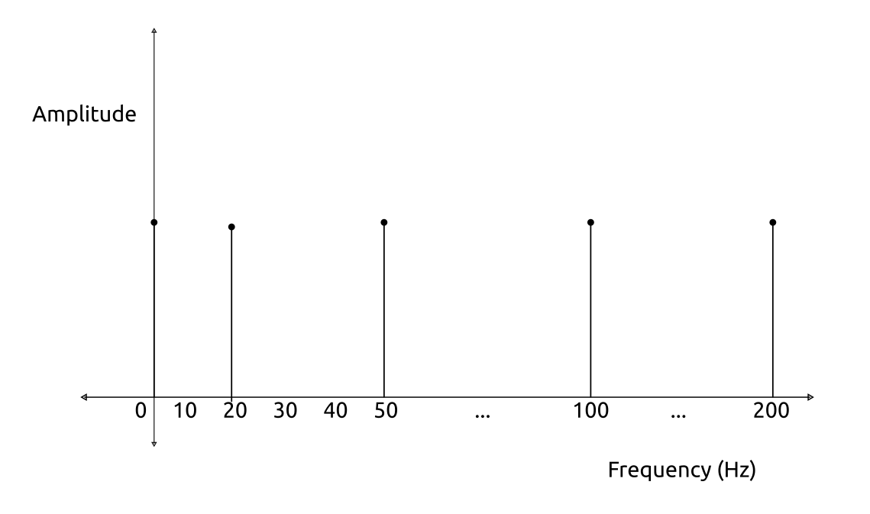
Bandwidth: 200 Hz (highest frequency) - 0 Hz (lowest frequency) = 200 Hz

P3-5. A periodic composite signal with a bandwidth of 2000 Hz is composed of two sine waves. The first one has a frequency of 100 Hz with a maximum amplitude of 20 V; the second one has a maximum amplitude of 5 V. Draw the bandwidth.
As the first frequency is 100 Hz and the bandwidth is 2000 Hz, then the second frequency will be 2100.

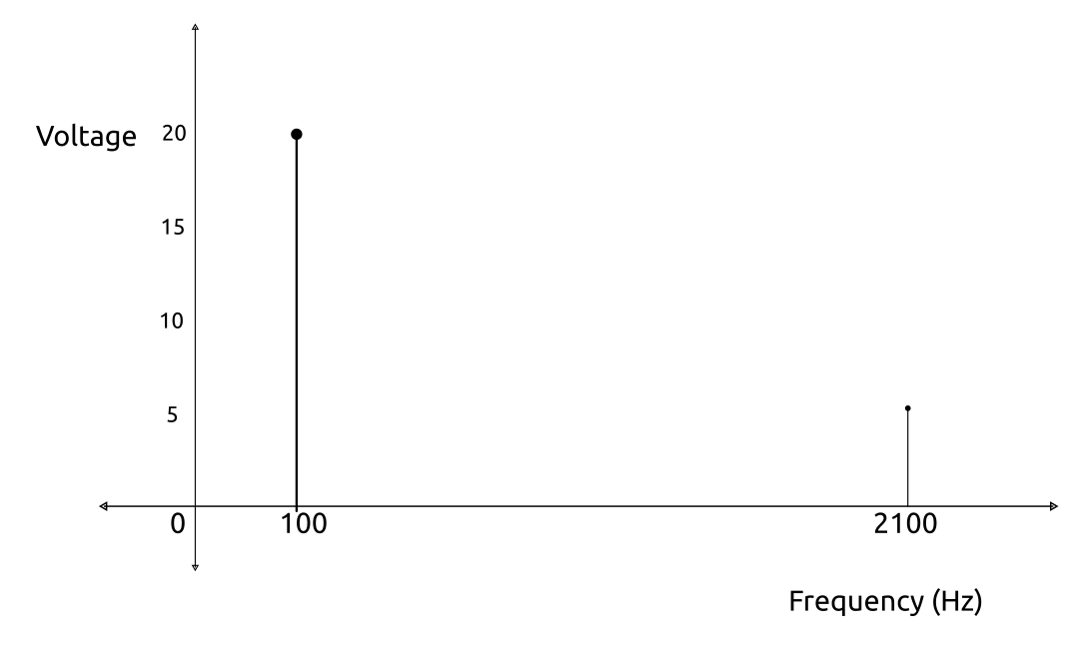
P3-6. Which signal has a wider bandwidth, a sine wave with a frequency of 100 Hz or a sine wave with a frequency of 200 Hz?
Bandwidth depends on the frequencies, so 200 Hz has more bandwidth.
P3-7. What is the bit rate for each of the following signals?
a. A signal in which 1 bit lasts 0.001 s

b. A signal in which 1 bit lasts 2 ms

c. A signal in which 10 bits last 20 μs

P3-8. A device is sending out data at the rate of 1000 bps.
a. How long does it take to send out 10 bits?

b. How long does it take to send out a single character (8 bits)?

c. How long does it take to send a file of 100,000 characters?
Let’s assume each character will take approximately 8 bits then we will need (100,000 x 8) or, 800,000 bits.

P3-9. What is the bit rate for the signal in Figure 3.35?


P3-10. What is the frequency of the signal in Figure 3.36?
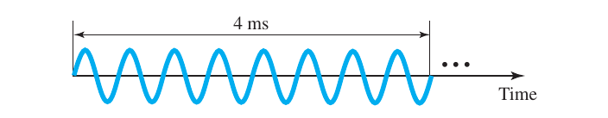

P3-11. What is the bandwidth of the composite signal shown in Figure 3.37?
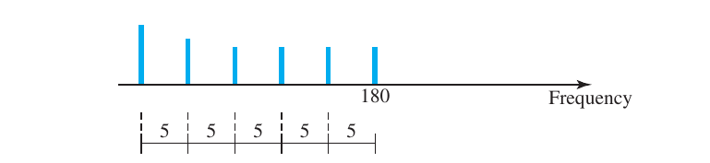
Bandwidth = 5 x 5 = 25 Hz.
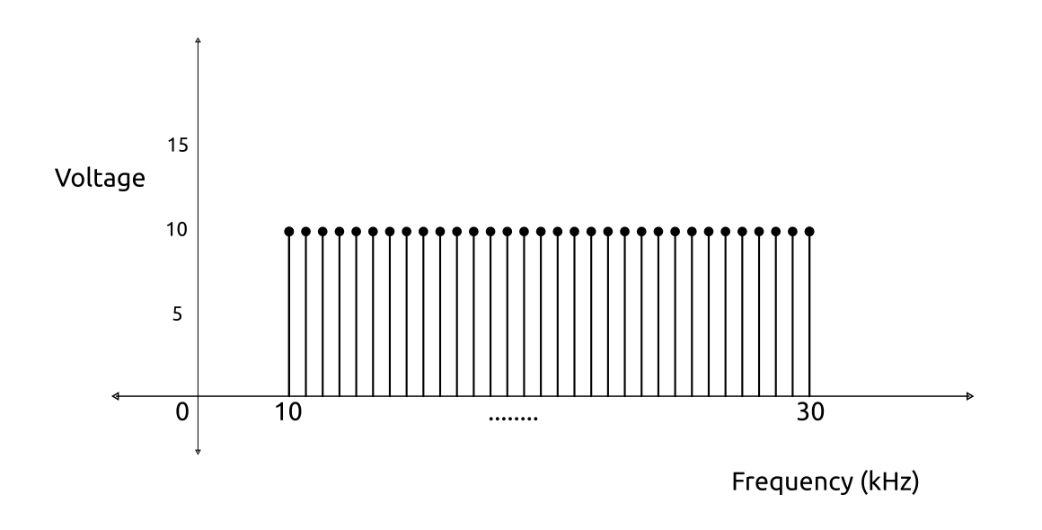
P3-12. A periodic composite signal contains frequencies from 10 to 30 KHz, each with an amplitude of 10 V. Draw the frequency spectrum.

P3-13. A nonperiodic composite signal contains frequencies from 10 to 30 KHz. The peak amplitude is 10 V for the lowest and the highest signals and is 30 V for the 20-KHz signal. Assuming that the amplitudes change gradually from the minimum to the maximum, draw the frequency spectrum.
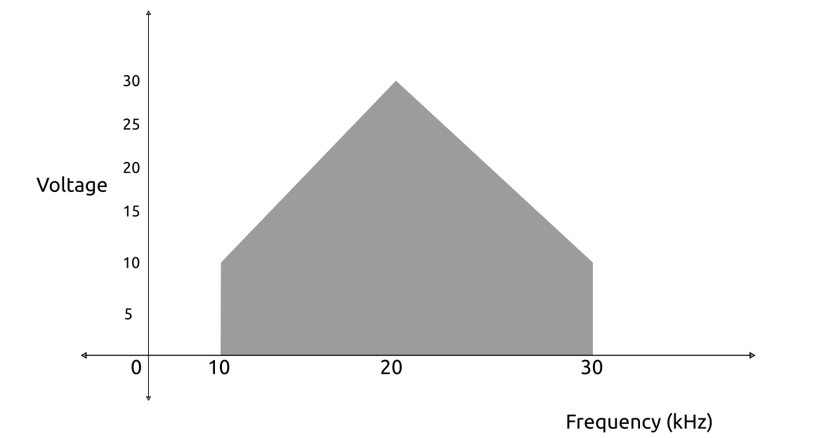
P3-14. A TV channel has a bandwidth of 6 MHz. If we send a digital signal using one channel, what are the data rates if we use one harmonic, three harmonics, and five harmonics?
As we have 6 MHz, a TV can utilize the whole channel for baseband transmission.
Here more harmonic has more frequencies. First harmonic has only one full cycle for two bits.
So for one harmonic
For three harmonic
For five harmonic

P3-15. A signal travels from point A to point B. At point A, the signal power is 100 W. At point B, the power is 90 W. What is the attenuation in decibels?
Attenuation = dB
= -0.4575 dB

P3-16. The attenuation of a signal is -10 dB. What is the final signal power if it was originally 5 W?
Attenuation = = -10
or, p = 0.5 W

P3-17. A signal has passed through three cascaded amplifiers, each with a 4 dB gain. What is the total gain? How much is the signal amplified?
Here the Number of Amplifier= 4
Total Gain = 4x3 = 12dB
If we consider the first signal and second signal to be P₁ and P₂, then,
or,
So the signal will be 15.85 times stronger than before.

P3-18. If the bandwidth of the channel is 5 Kbps, how long does it take to send a frame of 100,000 bits out of this device?
Transmission time = = 20 seconds

P3-19. The light of the sun takes approximately eight minutes to reach the earth. What is the distance between the sun and the earth?
Distance = .

P3-20. A signal has a wavelength of 1 μm in air. How far can the front of the wave travel during 1000 periods?
Distance = N x λ = 1 μm x 1000 = 1000 μm = 1 mm

P3-21. A line has a signal-to-noise ratio of 1000 and a bandwidth of 4000 KHz. What is the maximum data rate supported by this line?
Capacity =
=
= 39868.905035343974 kbps or, approximately 40 Mbps.

P3-22. We measure the performance of a telephone line (4 KHz of bandwidth). When the signal is 10 V, the noise is 5 mV. What is the maximum data rate supported by this telephone line?
Capacity =
=
= kbps

P3-23. A file contains 2 million bytes. How long does it take to download this file using a 56-Kbps channel? 1-Mbps channel?
File size=2 million bytes=2000000 x 8 bits=16,000,000 bits
If the channel speed is= 56,000 bps
Required time is = s
If the channel speed is= 1,000,000 bps
Required time is = s

P3-24. A computer monitor has a resolution of 1200 by 1000 pixels. If each pixel uses 1024 colors, how many bits are needed to send the complete contents of a screen?
Here, each pixel uses 1024 colors. So if we assume we need n bits,
so we can write,
or, bits.
Needed bits are = 1200x1000x10 = 12,000,000bits or, 12 Mb.

P3-25. A signal with 200 milliwatts power passes through 10 devices, each with an average noise of 2 microwatts. What is the SNR? What is the SNRdB?
Here, as signal pass through 10 devices,
Signal for per device= mW.
SNR =

P3-26. If the peak voltage value of a signal is 20 times the peak voltage value of the noise, what is the SNR? What is the SNRdB?

dB

P3-27. What is the theoretical capacity of a channel in each of the following cases?
a. Bandwidth: 20 KHz SNRdB = 40
b. Bandwidth: 200 KHz SNRdB = 4
c. Bandwidth: 1 MHz SNRdB = 20
We know that,
or,
So,
For bandwidth 20 kHz and SNR_{dB} = 40
bps
For bandwidth 200 kHz and SNR_{dB} = 4
bps
For bandwidth 1 MHz and SNR_{dB} = 20
bps

P3-28. We need to upgrade a channel to a higher bandwidth. Answer the following questions:
a. How is the rate improved if we double the bandwidth?
→ As the relationship is , if we double the bandwidth then we will also improve the rate if SNR is constant.
b. How is the rate improved if we double the SNR?
→ As the relationship is , here is a logarithmic relationship between C and SNR. So doubling the SNR will also increase the capacity.

P3-29. We have a channel with 4 KHz bandwidth. If we want to send data at 100 Kbps, what is the minimum SNRdB? What is the SNR?
We know
or,
or,
or,
And,

P3-30. What is the transmission time of a packet sent by a station if the length of the packet is 1 million bytes and the bandwidth of the channel is 200 Kbps?
Packet size = bits
Bandwidth =
Required time = seconds.

P3-31. What is the length of a bit in a channel with a propagation speed of 2 × 108 m/s if the channel bandwidth is
a.1Mbps
b.10Mbps
c.100Mbps

We know,
bit length = propagation speed x bit duration,
So, for 1 Mbps, bit length = m.
For 10 Mbps, bit length = m.
For 10 Mbps, bit length = m.

P3-32. How many bits can fit on a link with a 2 ms delay if the bandwidth of the link is
- 1 Mbps
- 10 Mbps
- 100 Mbps

Number of bits = bandwidth x delay
a. For 1 Mbps = 1xx2x=2000 bits
b. For 10 Mbps = 10xx2x=20,000 bits
c. For 100 Mbps = 100xx2x=200,000 bits

P3-33. What is the total delay (latency) for a frame of size 5 million bits that is being sent on a link with 10 routers each having a queuing time of 2 μs and a processing time of 1 μs. The length of the link is 2000 Km. The speed of light inside the link is 2 × 108 m/s. The link has a bandwidth of 5 Mbps. Which component of the total delay is dominant? Which one is negligible?
Processing time = s
Queuing time = s
Transmission time = s
Propagation time =
Hence, total time = 0.00001 + 0.00002 + 1 + 0.01 = 1.01003 s

Here the transmission time is dominant because the packet size is huge. And the processing or queuing time is negligible.

